Suffolk University Request for Proposal
Faculty-led Academic Travel Seminar

GENERAL INFORMATION

Program level (MBA/UG/EMBA)
Course Name and Number | i.e. Doing Business in Singapore
Faculty Name | Name, Title + Email
Main Point of Contact | Name, Title + Email
Travel Period | enter in the estimated dates of the program
Course Location | City/cities, Country
Estimated Number of Students | Student Numbers, grad/undergrad,
RFP Deadline | enter the RFP Deadline
Program Descriptions | one paragraph describing the program objectives and structure (elective, optional etc.)

PROGRAM TENTATIVE ITINERARY

Breakdown of the ideal structure of the program as using the following format:

NOTE: This is a tentative proposed itinerary and is subject to change. Once Suffolk determines the provider, we will revisit this proposed itinerary together with the faculty to determine the best final schedule.

Example Itinerary
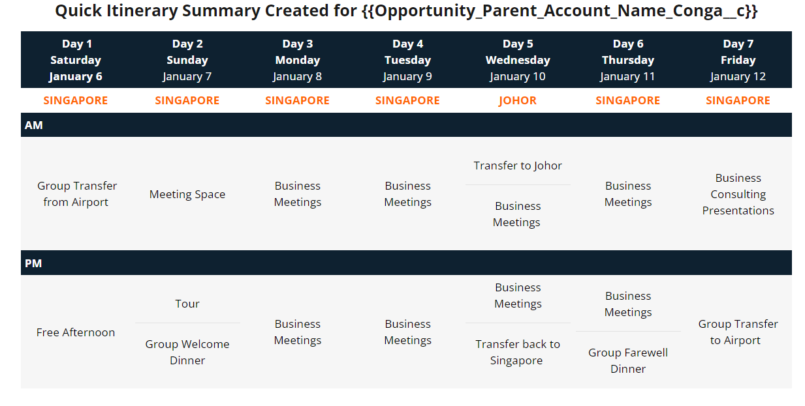

Proposed Itinerary

Day 1 | Day 2 | Day 3 | Day 4 | Day 5 | Day 6 | Day 7 | Day 8
[Day] | [Day] | [Day] | [Day] | [Day] | [Day] | [Day] | [Day]
[Date] | [Date] | [Date] | [Date] | [Date] | [Date] | [Date] | [Date]
[City] | [City] | [City] | [City] | [City] | [City] | [City] | [City]
AM
PM

Additional Comments:
____________________________________________________________________________________________________________________________________________________________________________________________________________________________________________________________________________________________________________________________________________________________________________________________________________________________________________________________________________________________________________________________________

List of Services Requested for the Program

Accommodations

General Stipulations:
- Students will be housed in double occupancy rooms with the possibility of singles in the
event of a gender imbalance (or single occupancy rooms)
- Double rooms must include two separate beds and private bathroom
- The faculty and administrator will be housed in single rooms.
- Accommodation should be handicap accessible and able to accommodate a variety of
- Have meal options for dietary restrictions (e.g. gluten free, vegetarian).

In the following section, please indicate your preferences regarding group lodging. If there is a specific property you would like to use, please indicate that. If there is not a specific property you would like to use only indicate the city, dates, and budget for each property.

city | City 1 | City 2 | City 3
Dates
Breakfast and Wifi included?
Property Name*
Hotel star rating*

*If known/needed

Additional Comments Notes: ______________________________________________________________________________________________________________________________________________________________________________________________________________________________________________________________________________________________________________________________________________________________________________________________________________________________________________

Transportation

We would like transportation to be arranged by the provider. Faculty, please indicate which of the following transport options you would like to be arranged by the provider.
- Group flight Yes ☐ No ☐
- Airport Transfer in/out Yes ☐ No ☐

Additional comments: ________________________________________________________________________________________________________________________________________________________________________________________________________________________________________________________________________________________________________________________________________________________

Group Meals

Please indicate your preferences by selecting the meal options for the program
Breakfast included at hotel every day | Yes/No
Welcome Dinner | Yes/No
Farewell Dinner | Yes/No
Group Lunches | Yes/No | [Please indicate how many and on which days]

For all lunches and dinners, please specify how many courses and how many soft drinks and alcoholic beverages should be included

 | # of courses | # of soft drinks
Welcome Dinner
Lunches
Farewell Dinner

Group Activities

Group activities are a combination of required academic visits, cultural visits, and service learning experiences. Guides are only be required for provider booked activities that require a guide. Please specify which group activities will need guides.

Cultural Visits

Please indicate which of the following types of cultural visits you would the partner to plan, and how many of each type of activity.

Activity | Needed | Guide Required | How many?
City Tour | [Yes/No] | [Yes/No]
Half-day Cultural Activity | [Yes/No] | [Yes/No]
Full-day Cultural Activity | [Yes/No] | [Yes/No]
Service Learning Activity | [Yes/No] | [Yes/No]

If there are specific cultural sites/locations/activities that you would like to have included, please list them below.

Site/location/activity | Goal of the visit

Additional Comments: ____________________________________________________________________________________________________________________________________________________________________________________________________________________________________________________________________________________________________________________________________________________________________________________________________________________________________________________________________________________________________________________________________

Academic and Business Visits

Activity | Guide Required | How many?
Business Visits | [Yes/No]
Academic Visits | [Yes/No]

Please indicate the industries or institutions that you would like to visit during the program along with the aim of the visit.
If there are specific academic or business sites/locations/activities that you would like to have included, please list them below.

Industry/Institution/Location | Academic Aim

Additional Comments: ____________________________________________________________________________________________________________________________________________________________________________________________________________________________________________________________________________________________________________________________________________________________________________________________________________________________________________________________________________________________________________________________________

Program Pricing

Please indicate your budget for the package cost per participant below.
 | Price Range | Comments
Cost Per Student 12-14
Cost Per Student 15-19
Cost Per Student 20+
Cost per faculty
Single supplement

*Remember to look at the budget worksheet for cost estimates

Please give any other comments or program specifics below:
______________________________________________________________________________________________________________________________________________________________
______________________________________________________________________________________________________________________________________________________________
______________________________________________________________________________________________________________________________________________________________
______________________________________________________________________________________________________________________________________________________________

